Real-time Bridge Monitoring
Guide to Inputs Conversion & Formulas calculation

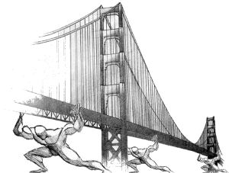
Index
1Type of Inputs 1
2Content of Inputs 2
2.1Analog files 2
2.2Echo-Sounder files 3
3Conversion operations on inputs 3
3.1Anemometer 3
3.2Hydrometer 3
3.3Echo-Sounder 4
4What kind the calculations are there to do? 5
4.1Anemometer (10min) 5
4.2Hydrometer (10min) 5
4.3Echo-Sounder (10min) 5
4.4Images 5
5Calculation of Forcing 6
5.1Pier / Stack compositions 6
5.2Push of the wind 7
5.2.1Effective speed 8
5.2.2Push of the wind on the planking 8
5.2.3Push of the wind on the traffic 9
5.3Hydrodynamic load (on the whole pier) 9
5.3.1Water speed 9
5.3.1.1Scale of flow rates 10
5.3.1.22D Analysis 10
5.3.2Water Thrust 10
5.4Weight of the structure (o the whole stack) 12
5.5Mobile loads / Traffic load 12
5.6Brake of vehicles 13
5.7Final remark on the forcing 13
5.8Reference system 14
6Forcing: from planking to the single line of pylons 16
6.1Weight of the planking 16
6.2Mobile loads (traffic combinations) 17
6.2.1A1 Combination 17
6.2.2A2 Combination 17
6.2.3A3 Combination 18
Traffic tables: 19
6.3Vehicle braking 20
6.4Wind 20
6.5Water 21
7Load combinations on the stack 22
7.1Combination 23
8Stress to the Level 4 / bases 25
8.1numbering of the individual pylons 25
8.2Introduction to the structural model 25
8.2.1y direction: flat frame 25
8.2.2x direction 25
8.3Geometry of the structural model (parameters from the parameters table) 26
8.4Summary of kind of forces acting on the frame 27
8.5Structure weight 28
8.6Vertical load N 29
8.7Bending moment 29
8.8Cutting force 30
8.9Distributed Load (qy) 31
8.10Cutting force Tx 34
8.11superposition principle 34
9Verification “Pressoflessione” 38
9.1M-N DOMAIN 38
9.2Explanation on how the web behavior of this information 40
9.2.1Tables of “grouped data” 40
9.2.2Table of “worst case” 41
10Table of parameters 43

Type of Inputs
here are three inputs:
- analog*********.txt → in this txt file there are the values measured by the Anemometer and the Hydrometer
- sonar**********.txt → in this file there are the values measured by the Echo-Sounder
- Modean[Mantova]********.jpg → there are the pictures taken by the two camera

How to interpret the ID/timestamp of a file
analog*********.txt  sonar**********.txt | For this two kind of files the ID represents the Labview encoding and corresponds at the number of seconds that have elapsed sing 1th January 1904, without time zone so on the meridian of Greenwich (and at the same way for the timestamp of the all values in the file)  http://www.ni.com/white-paper/7900/en/  (there are 2 file (.xlsx & .ods) on GitHub [DSD/Data Source] that do this conversion automatically, just insert the number of seconds in the cell)
Example  File: analog3383680299.txt  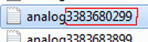  (fig. 1) | s = 3383680299 ← fig. 1  m=(3383680299 / 60) = 56394671  h = (56394671 / 60) = 939911  d = (939911 / 24) = 39162  y = (39162 / 365) = 107  rest of days = d - (y*365)=107  rest of hours = h - (d*24)=23  rest of minutes = m - (h*60)=11  rest of seconds = s – (m*60)=39  The rest of days is 107, and it's corresponds at the month of April because 107 is between the sum of the days till March(that is 90) and the sum of days till April (that is 120). So mean that 107 days remaining corresponds at the month of April, the 4th.  How many days in April? Easily April begin after 90days so 107-90=17days elapsed.  Ok, here we are:  Day 0 + results  y = 1904 + 107y = 2011  m= 0 + 04m = 04  d = 0 + 17d = 17  h = 00 + 23 = 23 h  m= 00 + 11 = 11 m  s = 00 + 39 = 39 s  This is the “normal” conversion; then we have to consider the leap years and correct the result in the right one. In the xlsx this is implemented. At the end, just correct with the correct time zone that for Italy, Croatia and Sweden is UTC+1.
Modean[Mantova]********.jpg | For the pictures the ID represents the exact date and time when the picture is taken
Example  File: mantova11032216564100.jpg    (fig. 2)  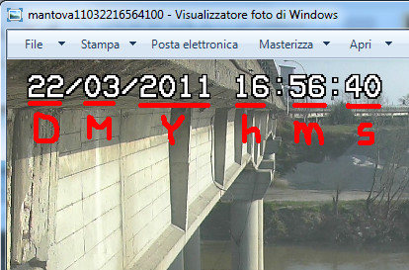(fig. 3) | As you can see in fig. 3 this picture is taken on 22/03/2011 (DD/MM/YYYY) at 16:56:40 (hh:mm:ss)  So this information are used to build the timestamp of the file, in this way:  Y = 2011 → 11 take only the last two number of the year  M= 03  D = 22  h = 16  m= 56  s = 40  concatenating all these numbers we obtain:  Y|M|D|h|m|s  110322165640  So if we compare this result and the file ID  110322165640 ← concatenation of values  11032216564100 ← timestamp of the file  is the same value except for the last two numbers that we can discard  As you can see, this file was saved just 1sec after the picture was taken.  Concluding, we can extract the date&time when a picture was taken, just reading the file ID.

Content of Inputs

Analog files
The analog file contains 4 columns of values (fig.4):
- Wind speed (unity measure Ampère)
- Distance between the Hydrometer and the level of water (unity measure Ampère)
- Wind direction (unity measure Ampère)
- Timestamp of the detection of the sample (Labview encode → see before)[decimals can be dropped]
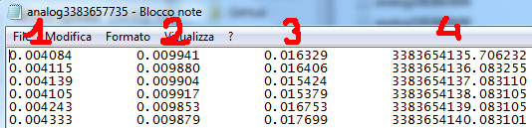

(fig. 4)

Echo-Sounder files
The echo-sounder file contains 2 columns of values, offset of a line (fig.5):
- Distance between the sonar and the river bed (unity measure meters)
- Timestamp of the detection of the sample (Labview encode → see before)
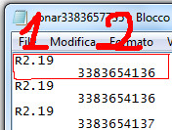
(fig.5)

Conversion operations on inputs
Every hour the system receives a packet in which there are an analog file and a sonar file, both files with at most 3600 values, and two images one for camera. All these values are to be converted from the parser into the db, in the table of sensor_raw_data. Each values has to fill one row of the table.

Anemometer
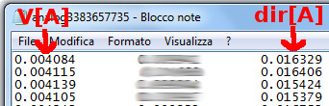
(fig.6)

- Speed →
- Direction →

Hydrometer

(fig.7)

- Distance hydrometer-water →
- Water height →

Echo-Sounder
For the sonar is a little bit more complicated because the sonar can produces five different kind of data.
- Correct data → Rxx.xx (can exist even one decimal)
- Uncertain data → Rxx.xxE (can exist even one decimal)
- Wrong data → xx.xx (can exist even one decimal)
- Sonar out of water → R99.99E
- Error → E1 or missing data

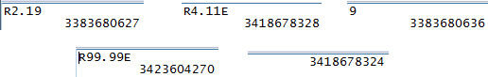

(fig.8)
The generic xx.xx is the distance in meter between the sonar and the height of the bottom.
- Height of the bottom →

Data that are of type ① and ② can be convert in a real height; for the other types this conversion is not possible but is necessary to store these information anyway, to compute some statistics that will explain later.

The data of type ③, ④ and ⑤ are not used to make calculations but will be saved into the db and on these data in future could be made some statistics. For now, is only a report that says how good is the behavior of the echo-sounder.

What kind the calculations are there to do?
To aggregate data for 10 minutes (1hour and/or 1 day), we have to manage 600 data as a single sample to calculate the needed information; these 600 data correspond to a sequence of 600 seconds starting from a given time istant.

Anemometer (10min)
- [ANE1] mean wind speed
- [ANE2] maximum wind speed in the 10 minutes
- [ANE3] mean wind direction
- [ANE4] direction of the maximum wind speed in the 10 minutes

Hydrometer (10min)
- [IDRO1] mean water height
- [IDRO2] variance of the sample

Echo-Sounder (10min)
- [SONAR1] mean value of the height of the bottom (only with data of type ① + ②)
- [SONAR2] variance of the sample (only with data of type ① + ②)
- [SONAR3] % of data of type “① + ②” used compared to the 600 elements of the sample
- [SONAR4] % of data of type “③” there are in the sample
- [SONAR5] % of data of type “④” there are in the sample
- [SONAR6] % of data of type “⑤” there are in the sample
- [SONAR7] % of data of type “②” there are, considering as sample the “① + ②” set of data (so not all the 600 data)

Images
The images don't need any kind of elaboration, they have only to be displayed.

Calculation of Forcing
The deck of the Borgoforte bridge is bore by many piers. Only one is monitored, number 30. This pier is composed by 2 independent rows of 3 piles (the 3 piles of each row are connected by 2 horizontal structures, superior beam, called "pulvino", and an inferior beam called "traverso"). The structural analysis does not include the entire bridge but a piece of it: the pier (number 30) and the related part of the deck (for instance, every weight or force applied to this part of the deck must be totally "absorbed" by the pier, in particular by each 6 piles)
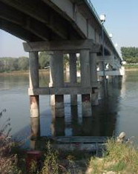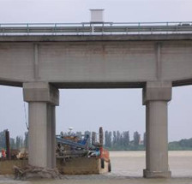
The logical steps are:
1) evaluate the force on the part of the bridge of pier 30 competence
2) transfer these forces from the deck to the pier
3) split this transferred force on the 2 independent rows
4) define the maximum stresses in each pile
For the most of the formulas, is needed the use of parameters; these parameters are in a db table that only who have a high level of authorization can change. The change of parameters causes the re-elaboration of the all data in the grouped tables (customers know it and accept it).

Pier / Stack compositions
The bridge is supported by various stacks/cells (call as you want, we have to choose and agree on one word) and each stack is composed by two line of three pylons connected together by a “pulvino” (fig. 9).
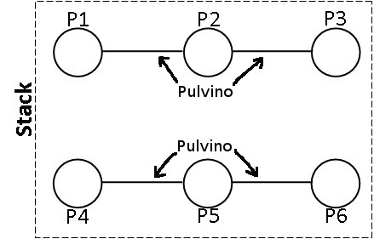
(fig.9)
The system has to calculate the forces acting on the stack and after, if is possible, has to divide these forces on the two lines of the stack and divide again on the three pylons of each line.

Push of the wind
The push of the wind is divided in two components:
- SVplank: is the push of wind on the planking.
- SVtraf: is the push of wind on the traffic.

Because the traffic is not monitored, we have to use a combinations of possible traffic scenarios; In this model were modeled three scenarios, named A1, A2 and A3 and each scenario is itself divided into two or four scenarios dependent on the direction of the traffic.
The scenarios are default scenarios that are used at design phase of any kind of structure of this type.

These are the traffic combinations:

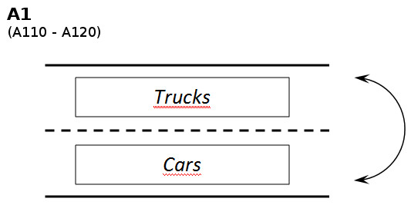
In this combination the push of wind on traffic is high because this is the combination that expected a huge amount of traffic in both directions and on the whole length of the plank.

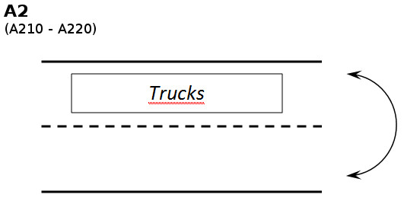
This combination that expected a traffic only in one direction but still for the whole length of the plank. Then the push is expected to be less than the previous one.

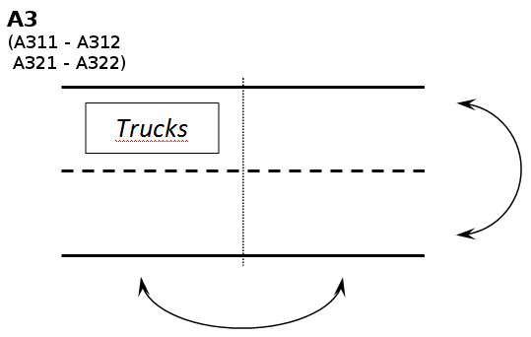
This combination expects the presence of traffic only in one direction and not for all the length of the plank portion on the pier. That mean the traffic is concentrated in one quarter, as you can see in the figure. That mean that wind push on the traffic will be minimum respects the other combinations but will have other major effects under other aspects that we will explain later in the document.

Effective speed
Before start to calculate the push of the wind on the whole bridge system, we must consider the real relevant value of the wind speed and not the general one. Is defined effective speed (VEFFwind) the wind component orthogonal to the bridge and to calculate it are needed:
- Measured wind speed → [ANE2]
- Measured wind direction → [ANE4]
- Planimetric inclination of the bridge from the north → α (parameter)

Push of the wind on the planking
For calculate this value are needed these information:
- “Drag planking” coefficient → CDwi (parameter)
- Air density → ρ (parameter)
- Planking area → A_{PLANK} (parameter)
- Effective wind speed → VEFFwind (see previous point)

Push of the wind on the traffic
For calculate this variable we must consider the three possible traffic scenarios, and also are needed:
- “Drag traffic” coefficient → CDwi (the same of previous point)
- Air density → ρair (the same of previous point)
- Surface of traffic → ATRAF (parameter)
- Aerial reduction coefficient → β₁ or β₂ (parameters)
- Effective wind speed → VEFFwind (see previous point)

For traffic combination A1:

For traffic combination A2 (the same of A1):

For traffic combination A3:

Hydrodynamic load (on the whole pier)
The water pressure on the pier depends on the presence or not of debris on the stack basement
As the same way of the wind, will be calculate all the loads and then choose at a later which consider.

Water speed
The hydrometer values provided by the customer, measure the height of the water, then we have to find a relation between the height of water and the water speed. To do this are needed:
- Scale of flow rates: correlates univocally the water height (hwater → [IDRO1]) and the flow rate (Q).
- Bidimensional analysis: allow to know for some flow rate value (Q) the relative value of water speed (Vwater)

Scale of flow rates
The following table show the relation between the flow rate (Q) and the water height (hwater). Depending on the value of hwater the parameters ai, bi and ci changes.
- a1, b1, c1 (parameters) for hwater < 17m
- a2, b2, c2 (parameters) for 17m < hwater < 22m
- a3, b3, c3 (parameters) for 22m < hwater < hMAXwater

hMAXwater = 25,3 m

Scale of estimate flow rates with fixed section
Parameters | [IDRO1] < 17m | 17m <[IDRO1]< 22m | 22m < [IDRO1] < hMAXwater (25,3m)
ai | 46 | 60 | 96
bi | -902 | -1350 | -2800
ci | 4658 | 8000 | 22500

if hwater > hMAXwater the river has overflowed.

2D Analysis
The relation between the flow rate of water and its speed are in the following table. Depending on the flow rate of water, you can identify the range and interpolate linearly to get the speed of water.

2D analysis – fixed bottom
hwater [m] | Q [m³/s] | V_{water} [m/s]
3 | 510 | 0,24
10,5 | 5400 | 2,73
14 | 10000 | 3,54

N.B.: the parameters a,b and c are different from the parameters a_{i}, b_{i} and c_{i}

Water Thrust
To calculate the water thrust are needed these information:
- “Drag planking” coefficient → CDwa (different parameter from that of the wind, see below)
- Water density → ρ (parameter)
- Stack area → Astack
- Water speed → Vwater (see point before)

The “Drag planking” coefficient depends on the presence (D=1) or not (D=0) of debris on the stack base. So the Drag Planking coefficient is split in:
- “Drag planking” coefficient (D=0) → CD0wa (parameter)
- “Drag planking” coefficient (D=1) → CD1wa (parameter)

The area of the stack invested by the flow of water depends on three factors:
- Presence (D=1) or not (D=0) of debris on the stack basement
- Height of the water → [IDRO1]
- Height of the bottom of the river –> [SONAR1]
- Shape of the stack; with presence of debris the shape of the stack changes, because the debris offer a greater surface on which the water can push.

The area of the stack is calculated using always the same formula, but depending on the scenario the coefficients involved change.

The hs is calculated independently by the presence or not of debris:
- [SONAR1] < bottom_ref → hs = [IDRO1] - bottom_ref
- [SONAR1] > bottom_ref → hs = [IDRO1] – [SONAR1]

The bottom_ref is a parameter.

The Bs, depends instead on the presence or not of debris:
- D=0 → Bs = Bs0 = 2*Dpylon
- D=1 → Bs = Bs1 = c

c and Dpile are parameters

At the end we have this formulas:
(D = 0) | (D = 1)

Weight of the structure (o the whole stack)
In this case we have to calculate the weight of the stack and the portion of planking which is competence of the pier. Most of the weight that will be considered are constant, the only variable is related about the portion of the pier exposed, so that portion that is measured as [SONAR1].

To calculate this value, are needed these information:
- Weight on the pier → PP (parameter)
- Weight of pulvino → Ppu (parameter)
- Weight of trunk pylon → Ptp (parameter)
- Weight of the beam → Pb (parameter)
- Weight per meter of the single pylon → Ppy (parameter)
- Height of the beam → hbeam (parameter)
- Height of stack portion exposed → to be evaluated with [SONAR1]

Mobile loads / Traffic load
As said before in point 5.2, the traffic is not monitored so we have to use combinations of load, to suite the common possible scenarios. The common combinations of loads used at design phase of a bridge are in general three and are A1, A2 and A3. At each combination was assigned a different contribute in terms of forces.
- A1 → N(A1), Mxx(A1) and Myy(A1)
- A2 → N(A2), Mxx(A2) and Myy(A2)
- A3 → N(A3), Mxx(A3) and Myy(A3)
The load combinations generate three kind of different forces: N is a vertical load, Mxx is the bending moment on the x-axis and Myy is the bending moment on the y-axis. The direction of the axes will be define later.
As explained in chapt. 5.2, the combinations of traffic are:
These are the traffic combinations:

We'll explain later the effects that each combination generates.

Brake of vehicles
In presence of traffic, there is the possibility of hard brakes by the vehicles that induce additional forces on the planking.
- FR → vehicles braking (parameter)

Final remark on the forcing
The forcing that act on the stack 30 are:
- Push of wind
- Hydrodynamic thrust
- Weight of the structure
- Mobile loads
- Brake of vehicles

The descriptions and the formulas presented until here allow to evaluate the generic force but say nothing about where this force is applied, if to the planking or directly to the stack or to both. The mainly purpose in to calculate the safety coefficient of the pier, all these generic forces must be transfer from the bridge to the pier. During this “transferring” could born some new forces or some forces could transform in other forces and so on. Moreover, all these forces and moments must be transferred also to the two lines of pylons that compose the single stack. At the end, we have to transfer each force from the row to each single pylon.

Reference system
Below will be present a schema of the reference system and the naming of forcing still transferred to the single line of pylon.

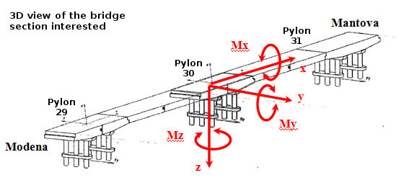
(fig. 10)

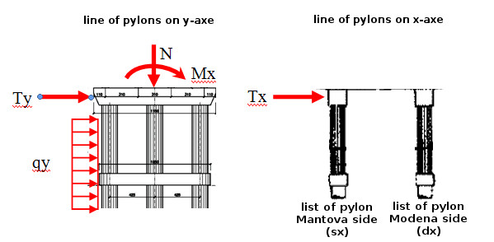
(fig. 11)

In these pictures, fig.10 and fig.11, are represented the generic forces acting on the stack, then each generic force contains the contributes of many forces.

The following table explain how the contributes are distributed into the generic force.

Chassis | Forces
Action | Weight | Mobile weight | Brake | Wind | Water
N | X | X | X
Ty |  |  |  | X
Tx |  |  | X
qy |  |  |  |  | X
Mx |  | X |  | X
My
Mz
(table 1)

To clarify this concept, for example think about the Mobile weights. Before was said that the Mobile weights, independently from the combination of traffic, exercise three kind of forces: N, Mxx and Myy. These three forces are applied to the planking and in their transfer to the single line of pylon, become N and Mx.

Forcing: from planking to the single line of pylons
Now we will take a look at each force acting on the bridge and how these forces are transferred from the planking to the single line of pylons.
The signs of the values ​​are all related with the reference system described in the previous chapter (fig.10 and fig.11).

Weight of the planking
The weight of the structure is composed by the weight of the planking that are on the stack (PP) and the weight of the stack itself. For calculate how the weight of the structure is split on the two lines of pylons we consider only the weight of the planking on the stack. The own weight of the stack will be added at the end.
In the following table there are the value of the forces resulting from the analysis.

Description |  | Line of pylons  Mantova side (sx) | Line of pylons  Modena side (sx) | Unity  measure
[N] | R1 = PP / 2 | +5355 | +5355 | kN
[N] | R2 = Mt/cspan | +1023 | -1023 | kN
[N] |  | +6378 | +4332 | kN

Mt ,c_{span} are both parameters.

Oss:
- The bridge structure is not symmetric respect the y-axis and that involves that the “plank + pier” system is not split equally on the pier structure, so not split equally on the two rows of pylons.
- The first [N] R1 contribute is made by the weight of the plank portion on the pier. This vertical load is a symmetric force.
- The second [N] R2 contribute is generated by the asymmetry of the bridge that generate a constant vertical load R2 with different sign on the two row; this because this R2 factor is generated by a bending moment and obviously is a row is loaded, the other is unloaded by the R2 contribute.
- At the end, the generic effects on the structure, on the single row on pylon is a resulting of sums between symmetric contributes and asymmetric contributes; as in this first table the [N] total force is a sum of a symmetric component R1 and an asymmetric component R2.

Mobile loads (traffic combinations)
For the traffic combinations are reported the three final tables in which are described the decomposition of the forces in the three components as mentioned in the paragraph 5.5.
Each combination will be duplicated in the next calculations due to the fact that the specific combination represents a double scenario because the traffic can be symmetrical (for example cars in left lane and trucks in right lane, but also the vice versa so trucks in left lane and cars in right lane). This stuff is represented by the possibility to the variables to change their sign.

These are the traffic combinations:

A1 Combination

In this combination we have the most height vertical load, due by the presence of traffic in both directions for the whole length of the plank portion of competence of the pier.
In this combination we have a medium bending moment generated on x-axis by the traffic weight, due by the presence of traffic in both directions for the whole length of the plank portion of competence of the pier; the bending moment generated by one direction is balanced by the bending moment generated by the opposite direction, then the resulting is not the highest.
The bending moment generated on y-axis is quite low because the traffic is distributed on the whole length of the plank portion.

A2 Combination

In this combination we have less vertical load respect the A1 combinations, due by the presence of traffic only in one of the two directions, always for the whole length of the plank portion of competence of the pier.
In this combination we have the highest bending moment generated on x-axis by traffic weight, due by the presence of traffic only in one direction for the whole length of the plank portion of competence of the pier; the bending moment generated is not balanced by the opposite direction, then the resulting is the highest.
The bending moment generated on y-axis is quite low because the traffic is distributed on the whole length of the plank portion. A little bit lower then the previous but still quite low.

A3 Combination

In this combination we have the minimum vertical load respect others combinations, due by the presence of traffic only in one of the two directions and only in half length of the plank portion of competence of the pier; so only one quarter of the road has traffic. For this reason the A3 combination has 4 sub-scenarios, one for each quarter.
In this combination we have the minimum bending moment generated on x-axis by traffic weight, due by the presence of traffic only in one direction and concentrated into a quarter of the plank portion; the bending moment generated is not balanced by the opposite direction but since there is less traffic, the result is not high.
The bending moment generated on y-axis is the highest of all, because the traffic is not distributed on the whole length of the plank portion and that accentuates the asymmetry of the structure, generating a big bending moment on y-axis.

Traffic tables:

ID | Combination | N (Wsl) | Mxx | Myy
ID | Combination | [kN] | [kNm] | [kNm]
A1 | 1-a | 4024 | 4368 | 3908
Description |  | Line of pylon Mantova side (sx) | Line of pylon Modena side (dx) | Unity Measure
[N] | R1 = (N/2) | + 2012 | + 2012 | kN
[N] | R2 = (Myy/cspan) | + 411 | - 411 | kN
[Mx] | M1 = (Mxx/2) | ± 2184 | ± 2184 | Knm

ID | Combination | N (Wsl) | Mxx | Myy
ID | Combination | [kN] | [kNm] | [kNm]
A2 | 1-b | 3166 | 8077 | 3015
Description |  | Line of pylon Mantova side (sx) | Line of pylon Modena side (dx) | Unity Measure
[N] | R1 = (N/2) | + 1583 | + 1583 | kN
[N] | R2 = (Myy/cspan) | ± 317 | ∓ 317 | kN
[Mx] | M1 = (Mxx/2) | ± 4038.5 | ± 4038.5 | kNm

ID | Combination | N (Wsl) | Mxx | Myy
ID | Combination | [kN] | [kNm] | [kNm]
A3 | 2-a | 1979 | 2121 | 25756
Description |  | Line of pylon Mantova side (sx) | Line of pylon Modena side (dx) | Unity Measure
[N] | R1 = (N/2) | + 989.5 | + 989.5 | kN
[N] | R2 = (Myy/cspan) | ± 2711 | ∓ 2711 | kN
[Mx] | M1 = (Mxx/2) | ± 1060.5 | ± 1060.5 | kNm

Vehicle braking
At the same way of the mobile loads, we can't know the direction the brake, then we have report the values in the following table with the corresponding signs.

Description |  | Line of pylons  Mantova side (sx) | Line of pylons  Modena side (sx) | Unity  measure
[Tx] | T1 = FR / 2 | ± 103 | ± 103 | kN
[N] | R1 = FR * n/cspan | ± 72 | ∓ 72 | kN

Wind
For the wind are still valid the considerations made before on the direction. The only different is that the wind direction is a value measured by monitoring, so we can know if its contribution is positive or negative.

Description |  | Line of pylons  Mantova side (sx) | Line of pylons  Modena side (sx) | Unity  measure
[Ty] | Fv = (Sv / 2) | ± Fv | ± Fv | kN
[Ty] | Rav = (SVplank * r/cspan) | ± Rav | ∓ Rav | kN
[Mx] | Mxv = [(SVplank * eplank + SVtraf * etraf) / 2] | ± Mxv | ± Mxv | kNm

For the [Ty] the Sv is the sum of SVplank + SVtraf, while r, eplank and etraf are parameters.

- A1 Combination

In this combination we have a the presence of traffic in both directions, so the wind push on traffic is very high because there is the most surface of traffic on which the wind can push.

- A2 Combination
In this combination we have a the presence of traffic only in one direction, so the wind push on traffic contribute is less than the previous, because we lost a whole line of surface traffic.

- A3 Combination
In this combination we have a the presence of traffic only in one direction and only in half of plank length, so the wind push on traffic contribute is lesser than the previous, because we lost also half traffic respect the A2 combination.

Water
The water thrust acts only on the stack, since the planking is at a higher level of riverbank; that is to say that the water can never reach the planking, so this force don't need to be transferred to from the planking to the pylons. The only operation is to transform a concentrated force on a distributed load, and split it equally on the two lines of pylons. The values sign is defined because the water can flow only in one direction.

Description |  | Line of pylons  Mantova side (sx) | Line of pylons  Modena side (sx) | Unity  measure
[qy] | qy = (SWATER / hs) / 2 | + qy | + qy | kN/m

Load combinations on the stack
Since some forces are not monitored, is not possible to know their direction and then the verse of these forces, that depending on the situations can stabilize or destabilize the whole structure.
To define in each moment the maximum stress scenario, we have to define load combinations which enclose all the possible situations.
In this table is reported, for each force, its contribution to the four generic resultant forces.

 | Line of pylons MANTOVA side (sx) |  |  |  |  |  | Line of pylons MODENA side (dx)
 | N | Tx | Ty | qy | Mx |  | N | Tx | Ty | qy | Mx
Pp | +R1 +R2 | 0 | 0 | 0 | 0 |  | +R1 -R2 | 0 | 0 | 0 | 0
 |  | 0 |  |  |  |  |  | 0
A110 | +R1 +R2 | 0 | 0 | 0 | +M1 |  | +R1 -R2 | 0 | 0 | 0 | +M1
A120 | +R1 +R2 | 0 | 0 | 0 | -M1 |  | +R1 -R2 | 0 | 0 | 0 | -M1
 |  | 0 |  |  |  |  |  | 0
A210 | +R1 +R2 | 0 | 0 | 0 | +M1 |  | +R1 -R2 | 0 | 0 | 0 | +M1
A220 | +R1 +R2 | 0 | 0 | 0 | -M1 |  | +R1 -R2 | 0 | 0 | 0 | -M1
A311 | +R1 +R2 | 0 | 0 | 0 | +M1 |  | +R1 -R2 | 0 | 0 | 0 | +M1
A312 | +R1 -R2 | 0 | 0 | 0 | +M1 |  | +R1 -R2 | 0 | 0 | 0 | +M1
A321 | +R1 +R2 | 0 | 0 | 0 | -M1 |  | +R1 -R2 | 0 | 0 | 0 | -M1
A322 | +R1 -R2 | 0 | 0 | 0 | -M1 |  | +R1 -R2 | 0 | 0 | 0 | -M1
FR01 | +R1 | +T1 | 0 | 0 | 0 |  | -R1 | +T1 | 0 | 0 | 0
FR02 | -R1 | -T1 | 0 | 0 | 0 |  | -R1 | -T1 | 0 | 0 | 0
VT0 | 0 | 0 | ± (Fv0 + Rav) | 0 | ± Mxv0 |  | 0 | 0 | ± (Fv0 - Rav) | 0 | ± Mxv0
VT1A1 | 0 | 0 | ± (FvA1 + Rav) | 0 | ± MxvA1 |  | 0 | 0 | ± (FvA1 - Rav) | 0 | ± MxvA1
VT1A2 | 0 | 0 | ± (FvA2 + Rav) | 0 | ± MxvA2 |  | 0 | 0 | ± (FvA2 - Rav) | 0 | ± MxvA2
VT1A2 | 0 | 0 | ± (FvA3 + Rav) | 0 | ± MxvA3 |  | 0 | 0 | ± (FvA3 - Rav) | 0 | ± MxvA3
AQD0 | 0 | 0 | 0 | qy | 0 |  | 0 | 0 | 0 | qy | 0
AQD1 | 0 | 0 | 0 | qy | 0 |  | 0 | 0 | 0 | qy | 0

Notes:
In the combination VT0 the bridge is ideally closed, so there is no traffic. The Fv0 identify the component of the wind force that acts only on the planking and the same thing with for the Mxv0.
-VT0 : wind thrust without traffic on the bridge
-VT1Ax: wind thrust with traffic of type A1 or A2 or A3 on the bridge
-AQDx: water thrust in presence or not of debris.

Combination
comb_01A | → | Pp |  | AQD0 |  | VT0
comb_01B | → | Pp |  | AQD1 |  | VT0
comb_02A | → | Pp |  | AQD0 |  | VT1A1 |  | A110 |  | FR01
comb_02B | → | Pp |  | AQD1 |  | VT1A1 |  | A110 |  | FR01
comb_03A | → | Pp |  | AQD0 |  | VT1A1 |  | A110 |  | FR02
comb_03B | → | Pp |  | AQD1 |  | VT1A1 |  | A110 |  | FR02
comb_04A | → | Pp |  | AQD0 |  | VT1A1 |  | A120 |  | FR01
comb_04B | → | Pp |  | AQD1 |  | VT1A1 |  | A120 |  | FR01
comb_05A | → | Pp |  | AQD0 |  | VT1A1 |  | A120 |  | FR02
comb_05B | → | Pp |  | AQD1 |  | VT1A1 |  | A120 |  | FR02
comb_06A | → | Pp |  | AQD0 |  | VT1A2 |  | A210 |  | FR01
comb_06B | → | Pp |  | AQD1 |  | VT1A2 |  | A210 |  | FR01
Comb_07A | → | Pp |  | AQD0 |  | VT1A2 |  | A210 |  | FR02
comb_07B | → | Pp |  | AQD1 |  | VT1A2 |  | A210 |  | FR02
comb_08A | → | Pp |  | AQD0 |  | VT1A2 |  | A220 |  | FR01
comb_08B | → | Pp |  | AQD1 |  | VT1A2 |  | A220 |  | FR01
comb_09A | → | Pp |  | AQD0 |  | VT1A2 |  | A220 |  | FR02
comb_09B | → | Pp |  | AQD1 |  | VT1A2 |  | A220 |  | FR02
comb_10A | → | Pp |  | AQD0 |  | VT1A3 |  | A311 |  | FR01
comb_10B | → | Pp |  | AQD1 |  | VT1A3 |  | A311 |  | FR01
comb_11A | → | Pp |  | AQD0 |  | VT1A3 |  | A311 |  | FR02
comb_11B | → | Pp |  | AQD1 |  | VT1A3 |  | A311 |  | FR02
comb_12A | → | Pp |  | AQD0 |  | VT1A3 |  | A312 |  | FR01
comb_12B | → | Pp |  | AQD1 |  | VT1A3 |  | A312 |  | FR01
comb_13A | → | Pp |  | AQD0 |  | VT1A3 |  | A312 |  | FR02
comb_13B | → | Pp |  | AQD1 |  | VT1A3 |  | A312 |  | FR02
comb_14A | → | Pp |  | AQD0 |  | VT1A3 |  | A321 |  | FR01
comb_14B | → | Pp |  | AQD1 |  | VT1A3 |  | A321 |  | FR01
comb_15A | → | Pp |  | AQD0 |  | VT1A3 |  | A321 |  | FR02
comb_15B | → | Pp |  | AQD1 |  | VT1A3 |  | A321 |  | FR02
comb_16A | → | Pp |  | AQD0 |  | VT1A3 |  | A322 |  | FR01
comb_16B | → | Pp |  | AQD1 |  | VT1A3 |  | A322 |  | FR01
comb_17A | → | Pp |  | AQD0 |  | VT1A3 |  | A322 |  | FR02
comb_17B | → | Pp |  | AQD1 |  | VT1A3 |  | A322 |  | FR02

Each of these combinations will provide a set of values N, Tx, Ty, qy and Mx with their specific signs that identify the forces direction.
At each combinations must be add the weight of the stack because, as said before, was “ignored” in the calculations of the force due by the weight of the structure.
This mean that the generic resultant force N must be increased to a NPs.

Defined
→

Now, using the structural model is possible to determine the stresses in the six pylons and be able to choose the most stressed pylon, identifying the load combination that generates it.

Stress to the Level 4 / bases
Before provide the formulas that allow to determine the stresses at the bases of the six pylons that compose the stack n.30, is needed to introduce some information and schemes.

numbering of the individual pylons
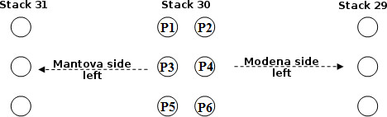
(fig. 12)

Introduction to the structural model

y direction: flat frame
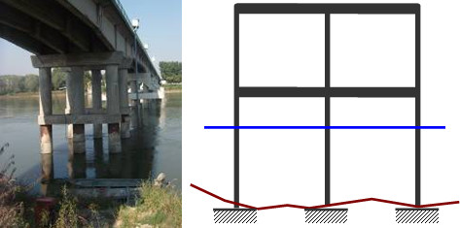
(fig. 13)

x direction
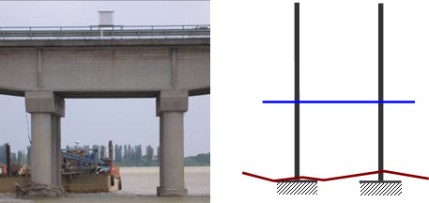
(fig. 14)

Geometry of the structural model (parameters from the parameters table)
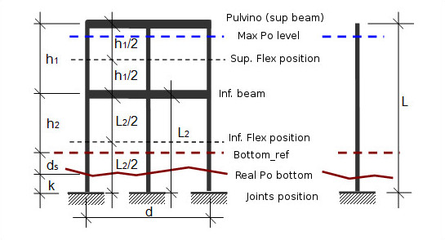
(fig. 15)

Distance | Value | Notes
L | variable | Depends by ds
L2 | variable | Depends by ds
h1 | 7.30 [m] | Parameter
h2 | 7.50 [m] | Parameter
(h1)/2 | 3.65 [m] | Parameter
(L2)/2 | variable | Depends by ds
ds | variable | Depends by the monitoring
d | 8.5 | Parameter (frame width)
k | 0 [m] | Parameter (by hypothesis)

Notes:
The geometry provided in the pictures before, defined some distances that are present in the final formulas. All these parameters must be put into the parameters table.
The formulas reported below contain many parameters that up to day are set to zero (or to a default value) due to a lack of specific information.

Summary of kind of forces acting on the frame
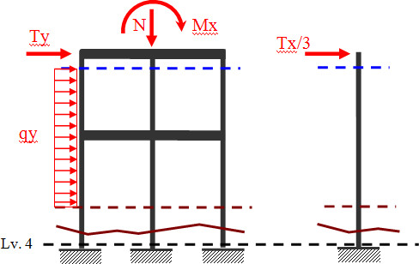
(fig. 16)

At this point the generic force is not more directly related to an external load (wind, water, traffic...), but at the sum of the all external forces contributions. Is reminded that the vertical force N, has not inside the pier weight.
All these forces are calculated and split in three parts for a single row, but is reminded that the two row are not loaded in the same way, so is needed to double the reasoning and the calculations during the implementation.
Last note is for Level 4: we'll use this call name to refer to the joints/base level of the pylons. So when we write Level 4 we mean at joints /base level of the structure or the single pylon.

Structure weight
In the figure below are represented only the the stack weight and how it is distributed; the pier weight is not an external load by definition, so we didn't unify it with the external load N even if acts in the same direction. For this reason we calculate this term separated by the external load N; at the end of course we have to sum these two contributions, but is logical correct to kept these two terms separated until the end of calculations because mean different things.
The picture shows how the weight of the frame is distributed on itself. The weights of the pier split in pulvino weight (qpu), pylon weight (qp) and beam weight (qb); all these weight are “weight/meter”, so each weight has to be multiplied by the length on which it is distributed.
As said before, the section at the pylon base is named “Level 4” and we'll use this term to refer to the base of the pylon structure.

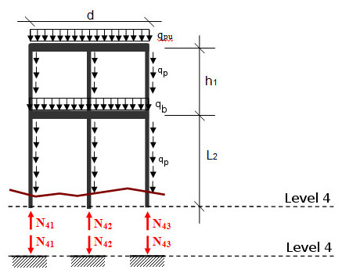
(fig. 17)

The weight of the truck stack (pts)is equal to qp*h1

The generic formula is the previous, but we have calculate that value yet before with this other formula:

So in own calculation flow process we calculate this value with the second formula that is specific for this structure.

Vertical load N
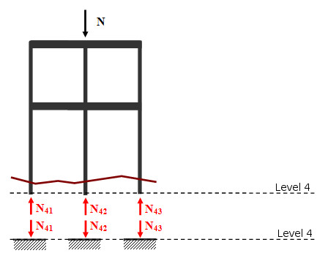
(fig. 18)

Bending moment
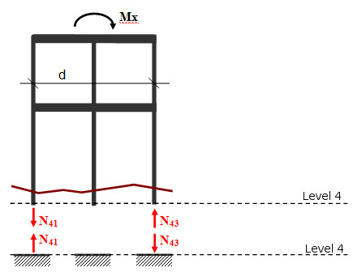
(fig. 19)

Cutting force

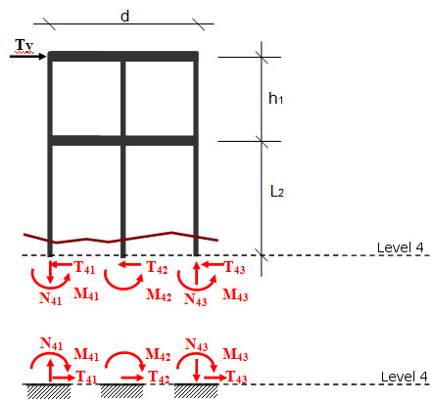
(fig. 20)

Distributed Load (qy)
This topic is not easy to discuss at the level 4, because the area of interest is variable since depends on the level of the river. For simplicity are evaluated only two cases: case A in which the level of the river is higher than the inferior beam and case B in which the level of the river is lesser than the inferior beam, like in the figure below.

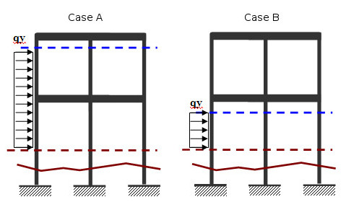
(fig. 21)

Later, is replaced the generic distributed load with a system of concentrated equivalent forces. For a better understanding, are reported the all steps to determine the equivalent concentrated forces.

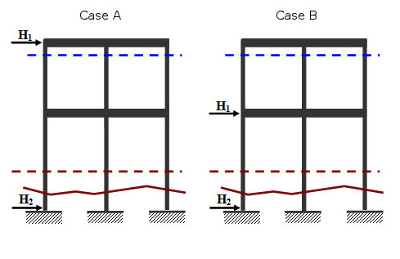
(fig. 22)

Once determined the resulting H, its moment is balanced respect at level 4 / base, point A fig23, with the component H1 that is the only component that generates a moment; the other component H2 is obtained by difference.

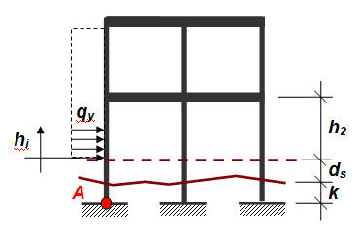
(fig. 23)

Case A hi >= h2 | Case B hi < h2
Calculation of the resulting H
Calculation of the moment of H, respect to point A
Calculation of H1, equaling the moment of H
Calculation of H2 by difference

Even if the concentrated forces for both configurations have the same encoding (H1 and H2), their values are different, since derive from a different distribution of qy.

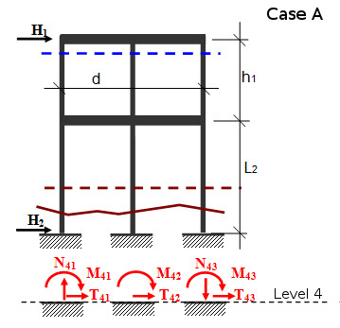

(fig. 24)

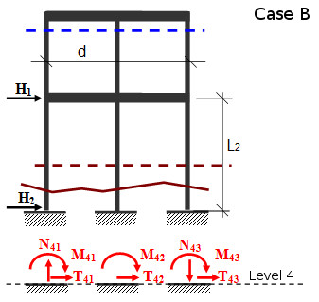

(fig. 25)

This note allow to define the case B as a particular case of case A: if the Po level was lower than the beam, the formula of the axial stress of case A should reset the h1 height. Next are identify the end formulas in their range of use.

 | Case A (hi >= h2) | Case B (hi < h2)
N
T
M

Cutting force Tx
The chassis subject to a force Tx, has a structural behaves like a “shelf”. The figure below defines the stresses that this Tx force make on the level 4. Remember that Tx/3 is the force that acts on the single pylon.

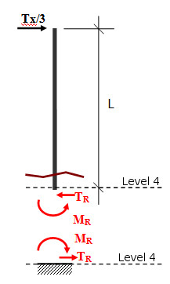

(fig. 26)

superposition principle
The stresses that each force generates at the level 4 can be simply added, determining the total stresses. The representation of this process will be show separating the stresses at the level 4 and explaining this stress for each of the three pylons. To be general, the formulas will be refer to the three pylons of the generic line not with the encoding of page 19 (fig. 12) but with the simple encoding of 1, 2 and 3. So the formulas are valid for both of the lines of the stack. Moreover the generic stress will have a subscript that identify the direction (x or y) and the reference section, the number 4. In the following tables, from 2 to 6 are defined respectively the stresses at the level 4: axial force N, cutting force Tx, cutting force Ty, bending moment Mx and bending moment My.

Axial stress N
 | Pylon 1 | Pylon 2 | Pylon 3
P.P.
N
Ty
Mc
qy
Tx

Tab.2: contributions of singles forces to the axial stress N

Cutting force Tx
 | Pylon 1 | Pylon 2 | Pylon 3
P.P.
N
Ty
Mc
qy
Tx

Tab.3: contributions of singles forces to the cutting action Tx
Cutting force Ty
 | Pylon 1 | Pylon 2 | Pylon 3
P.P.
N
Ty
Mc
qy
Tx

Tab.4: contributions of singles forces to the cutting action Ty

Blending stress Mx
 | Pylon 1 | Pylon 2 | Pylon 3
P.P.
N
Ty
Mc
qy
Tx

Tab.5: contributions of singles forces to the stress Mx

Blending stress My
 | Pylon 1 | Pylon 2 | Pylon 3
P.P.
N
Ty
Mc
qy
Tx

Tab.6: contributions of singles forces to the stress My

Verification “Pressoflessione”
Pressoflessione: combined compression and bending

M-N DOMAIN
1) PARAMETER DATA
External radius | 75 | cm
Internal radius | 0 | cm
Number of identical bars | 12 | --
Bars diameter | 2,4 | cm
Barycentric concrete cover | 4,2 | cm
Steel class | FeB44K | --
Concrete class | C25/30 | --
tab. 7
These are other parameters (tab. 7) to add at the parameters tables in the DB. This parameters are used to calculated the M-N domains and is not important how is the calculation because we receive directly the table with the values to can draw the domain graph/graphs.
The value M of a pylon is easily calculated with:
The idea is that each pylon has at the end 2 resulting forces: N and M. Then we can “put” each pylon into the graph to see if the pylon is in or not into the domain. If the pylon is in, the pylon is “ok”, but if the pylon is out it is in a very dangerous situation from a structural point of view.
So, pylon in → ok, pylon out → danger.
The safety factor (critical factor) is the expression of the pylon position into the domain, I mean that a pylon close to the axes origin represents a minor dangerous situation than a pylon that still is in the domain but is close to the domain bound because with a little variations of the conditions this pylon could cross the domain border and transforms in a dangerous situations.
So, the safety factor is a value that represents this “proximity” to the domain bounds, more a pylon is close to the domain bound more dangerous is the situation.
However, the calculation of this “proximity” is not an easy calculation and we proceed with two way in parallel:
- Approximation thought linearization of the proximity
- Representations of the six pylons of the worst load combination selected with the approximation at previews point, into the M-N domain as the EU 305/2011 Regulation requires.

The following table (tab.8) contains the values that describe the M-N domain, and also these values have to be stored into the db, maybe in another table. In this way also the View part can reads these value to be able to plot them.
Into graph M-N DOMAIN (1) is represented the more simple M-N domain with the values in tables, but we could add other M-N domain into DB to define different work areas of the structure. For instance the other graph M-N DOMAIN (2) represents two different domains: into the pink one all is “ok”, between pink and blue → “attention” and then if out of blue → “fast reaction or good bye bridge”.
2) M-N DOMAIN VALUES
Point | N1 (kN) | M1 (kNm)
1 | -2029,78 | 0
2 | -1895,17 | 96,4807
3 | -1673,87 | 254,95
4 | -1401,65 | 446,55
5 | -1078,88 | 660,403
6 | -241,319 | 1188,31
7 | 3104,27 | 2887,33
8 | 4622,78 | 3468,79
9 | 7466,71 | 4210,28
10 | 13342,2 | 4572,35
11 | 15880,5 | 4222,35
12 | 18998,7 | 3480,02
13 | 22632,8 | 2136,98
14 | 24958,6 | 1016,27
15 | 26441 | 293,541
16 | 27023 | 0
17 | 26441 | -293,541
18 | 24958,6 | -1016,27
19 | 22632,8 | -2136,98
20 | 18998,7 | -3480,02
21 | 15880,5 | -4222,35
22 | 13342,2 | -4572,35
23 | 7466,71 | -4210,28
24 | 4622,78 | -3468,79
25 | 3104,27 | -2887,33
26 | -241,319 | -1188,31
27 | -1078,88 | -660,403
28 | -1401,65 | -446,55
29 | -1673,87 | -254,95
30 | -1895,17 | -96,4807
31 | -2029,78 | 0
Tab.8
OSS: we don't know the formulas to calculate the domain values. We receive the tables already filled.
The M-N domain table in the database has this schema:
m_n_domain
+-----------------------+-----------+------+-----+-------------------+-----------------------------+
| Field | Type | Null | Key | Default | Extra |
+-----------------------+-----------+------+-----+-------------------+-----------------------------+
| ID | int(10) | NO | PRI | NULL | auto_increment |
| N | float | NO | | NULL | |
| M | float | NO | | NULL | |
+-----------------------+-----------+------+-----+-------------------+-----------------------------+

Explanation on how the web behavior of this information
The last database design changes are the following:

Tables of “grouped data”
sensor_data_10_min /sensor_data_1_hour /sensor_data_1_day
+-----------------------+-----------+------+-----+-------------------+-----------------------------+
| Field | Type | Null | Key | Default | Extra |
+-----------------------+-----------+------+-----+-------------------+-----------------------------+
| ID | int(10) | NO | PRI | NULL | auto_increment |
| wind_speed | float | NO | | NULL | |
| wind_direction | float | NO | | NULL | |
| wind_speed_max | float | NO | | NULL | |
| wind_direction_max | float | NO | | NULL | |
| hydrometer | float | NO | | NULL | |
| hydrometer_variance | float | NO | | NULL | |
| sonar | float | NO | | NULL | |
| sonar_variance | float | NO | | NULL | |
| sonar_perc_correct | float | NO | | NULL | |
| sonar_perc_wrong | float | NO | | NULL | |
| sonar_perc_outOfWater | float | NO | | NULL | |
| sonar_perc_error | float | NO | | NULL | |
| sonar_perc_uncertain | float | NO | | NULL | |
| safety_factor_00 | float | NO | | NULL | |
| stressed_pylon_00 | int | NO | | NULL | |
| safety_factor_01 | float | NO | | NULL | |
| stressed_pylon_01 | int | NO | | NULL | |
| safety_factor_10 | float | NO | | NULL | |
| stressed_pylon_10 | int | NO | | NULL | |
| safety_factor_11 | float | NO | | NULL | |
| stressed_pylon_11 | int | NO | | NULL | |
| water_speed | float | NO | | NULL | |
| water_flow_rate | float | NO | | NULL | |
| timestamp | timestamp | NO | | CURRENT_TIMESTAMP | on update CURRENT_TIMESTAMP |
+-----------------------+-----------+------+-----+-------------------+-----------------------------+

- In these tables are stored the information about the safety factor in the whole four traffic combinations, so 00, 01, 10 and 11. For the web view this four columns are used to show the critical factor related to what the user has selected on the checkbox (or what you have choose to use as selection element). Also these four columns are used in the historical page, to show the trend of the safety factor in time.

- Other two new columns are added and are “water speed” and “water flow rate”; these two information are requested from the customer because can be useful to the engineers know those values.

- There are no more the four columns of the “stressed_pylon_xx” because these information can be associated in a univocally way to the safety factor, because we don't monitoring the traffic so we can't know what is the pylon that the worst combination between those of type XX is stressing more, because also into the same type of combinations the forces and their direction changes and then also change the more stressed pylon.

- To be able to represent this kind on information about the situation of the pylons we have to do a more general situation for each traffic combination; below is explained it.

Table of “worst case”

worst_case_00 / worst_case_01 / worst_case_10 / worst_case_11
+-----------------------+-----------+------+-----+-------------------+-----------------------------+
| Field | Type | Null | Key | Default | Extra |
+-----------------------+-----------+------+-----+-------------------+-----------------------------+
| ID | int(10) | NO | PRI | NULL | auto_increment |
| pylon_number | int | NO | | NULL | |
| N | float | NO | | NULL | |
| Tx | float | NO | | NULL | |
| Ty | float | NO | | NULL | |
| Mx | float | NO | | NULL | |
| My | float | NO | | NULL | |
| M | float | NO | | NULL | |
| cs | float | NO | | NULL | |
| comb_number | float | NO | | NULL | |
| timestamp | timestamp | NO | | CURRENT_TIMESTAMP | on update CURRENT_TIMESTAMP |
+-----------------------+-----------+------+-----+-------------------+-----------------------------+

In these four new tables are stored the information about the worst case for each pylon for each kind of combination. This mean that in the table “worst_case_00” there are the information about all the six pylons, one pylon per row. In each row there is stored the information on the forces acting on that pylon in its worst case between the whole combination of kind 00 (there is only one combo for type 00 and 01, but the idea and the algorithm are the same). Then are stored the c.s. (safety factor) and the combo number that generate that c.s.

These tables have to been used into the view part, in this simple way. Each row of a table represents the information about the worst situation of each pylon in this specific combination and the columns “N” and “M” are the coordinates of the specific pylon into the M-N Domain (see chapt. 9.1) so the view part can use these data to represent all the six pylons into the M-N Domain graph for the specific combination of T-D user selection.

As the same way the view change the showed safety factor value based on the selection of T-D checkbox (or anything we thought to use to let the user to make a selection), the view should change the M-N Domain graph based on this selection and read coordinates from the correct table of worst case.

In each table of worst case should be stored only the last useful data about pylons situation so the respective dao object used by the view module, has to do only a select * from the correct table and then the view module has just to show in the graph the pylons (example in fig. 27)

The following picture is an example of what the user should see on the current state view page relative at the M-N domain and pylons situation.

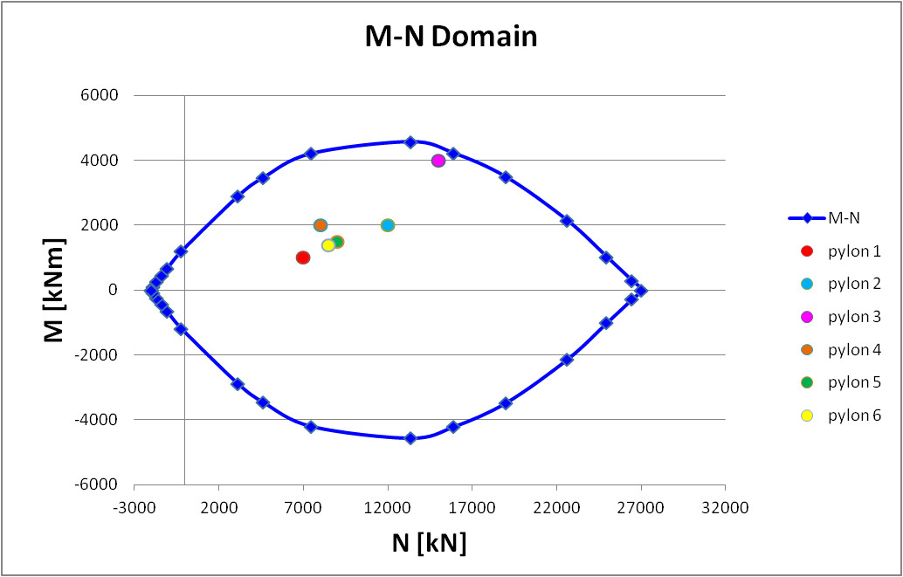
(fig. 27)

To draw the M-N domain has to be use the value into the M-N table into the database.
For the M-N domain information see the previous chapt. 9.1 on the M-N Domain.

Table of parameters
GEOMETRY OF THE STACK N.30 (9)
Dpylon | 1.5 | m | Diameter of the pylon
cspan | 9.5 | m | Distance between two line of pylon
hbeam | 17.5 | m | Height of the lower beam
bottom_ref | 10 | m | Height of the reference of the bottom of the river
h1 | 7.3 | m | Distance between the pulvino and the inferior beam
h2 | 7.5 | m | Distance between the inferior beam and the bottom_ref
(h1)/2 | 3.65 | m | Mean value of h1
k | 0 | m | Sinking of the bases over the ground
d | 8.5 | m | Width of the chassis
RIpylon | 0 | m | Internal radius
numb_id_bar | 12 | -- | Number of identical bars
Dbar | 0,024 | m | Bars diameter
Ccb | 0,042 | m | Barycentric concrete cover
Steel_class | FeB44K | -- | Steel class
Concrete_class | C25/30 | -- | Concrete class
WIND THRUST (10)
α | 6 | ° | Planimetric anticlockwise inclination of the bridge form the north
CDwi | 2 | - | “Drag planking” coefficient
ρair | 1.2 | Kg/m3 | Air density
Astack | 168 | m2 | Planking area exposed to the wind pressure
Atraf | 177 | m2 | Surface of traffic exposed to the wind pressure
β1 | 1 | - | Coefficient of reduction for A1 and A2 traffic scenarios
β2 | 0.5 | - | Coefficient of reduction for A3 traffic scenario
r | 2.25 | m | Thrust center due to longitudinal asymmetry, only of SVplank
eplank | 1.91 | m | “arm” for bending moment of SVplank
etraf | 3.41 | m | “arm” for bending moment of SVtraf
HYDRODYNAMIC THRUST (19)
CD0wa | 2.4 | - | “Drag planking” coefficient (D=0)
CD1wa | 2 | - | “Drag planking” coefficient (D=1)
ρwater | 1000 | Kg/m3 | Water density
βA | 0.5 | - | Area reduction for D=1
a | -0.0014 | - | Coefficient for the relation Vwater([IDRO1])
b | 0.0341 | - | Coefficient for the relation Vwater([IDRO1])
c | 0.052 | - | Coefficient for the relation Vwater([IDRO1])
hwater1 | 17 | m | Height limit of the river for parameters a1,b1,c1
a1 | 46 | - | Coefficient for Q(h) when [IDRO1] < hwater1
b1 | -902 | - | Coefficient for Q(h) when [IDRO1] < hwater1
c1 | 4658 | - | Coefficient for Q(h) when [IDRO1] < hwater1
hwater2 | 22 | m | Height limit of the river for parameters a2,b2,c2
a2 | 60 | - | Coefficient for Q(h) when [IDRO1] < hwater2
b2 | -1350 | - | Coefficient for Q(h) when [IDRO1] < hwater2
c2 | 8000 | - | Coefficient for Q(h) when [IDRO1] < hwater2
hmax | 25.3 | m | Max height level of river and limit for use parameter a3,b3,c3
a3 | 96 |  | Coefficient for Q(h) when hwater2 < [IDRO1] < hmax
b3 | -2800 |  | Coefficient for Q(h) when hwater2 < [IDRO1] < hmax
c3 | 22500 |  | Coefficient for Q(h) when hwater2 < [IDRO1] < hmax
WEIGHT OF THE STACK (6)
Pp | 10710 | kN | Plank weight on the stack
Ppu | 1680 | kN | Weight of single pulvino
Ptp | 1601 | kN | Weight of the trunk of pylon
Pb | 1007 | kN | Weight of the single beam
Ppy | 44 | kN/m | Weight per meter of pylon
Mt | 9720 | kNm | Moment generated by asymmetry
MOBILE WEIGHTS (9)
N(A1) | 4024 | kN | Axial load for load combination A1
Mxx(A1) | 4368 | kNm | Bending moment for load combination A1
Myy(A1) | 3908 | kNm | Bending moment for load combination A1
N(A2) | 3116 | kN | Axial load for load combination A2
Mxx(A2) | 8077 | kNm | Bending moment for load combination A2
Myy(A2) | 3015 | kNm | Bending moment for load combination A2
N(A3) | 1979 | kN | Axial load for load combination A3
Mxx(A3) | 2121 | kNm | Bending moment for load combination A3
Myy(A3) | 25756 | kNm | Bending moment for load combination A3
Vehicle braking (2)
Fr | 206 | kN | Value of the force due to the vehicle braking
n | 3.3 | m | “arm” for the vehicle braking moment

